**MODULE: 1**

**SE – Overview of IT Industry**

**1. What is software? What is software engineering?**

-> **Software:** Software refers to a set of instructions or programs that enable a computer to perform specific tasks. It includes operating systems and applications to scripts and libraries that gives facility of various functions on electronic devices.

-> **Software Engineering:** Software engineering is a systematic approach to the design, development, testing, and maintenance of software. It involves applying engineering principles to the entire software development process, aiming to create reliable, efficient, and scalable software systems.

**2. Explain types of software.**

-> Types of software’s: -

**System Software:** Essential for the functioning of computer hardware, including operating systems, device drivers, and utilities.

**Application Software:** Designed for specific tasks or user needs, such as word processors, web browsers, and graphic design programs.

**Development Software:** Tools for creating software, including compilers, debuggers, and integrated development environments (IDEs).

**Middleware:** Connects different software components or applications, facilitating communication and data management.

**Embedded Software:** Found in embedded systems and devices, controlling specific functions like in household appliances, cars, or medical devices.

**Network Software:** Manages communication between computers in a network, such as protocols, firewalls, and network operating systems.

**Business Software:** Supports business processes, including enterprise resource planning (ERP), customer relationship management (CRM), and office suites.

**Entertainment Software:** Includes video games, multimedia applications, and virtual reality experiences.

**3. What is SDLC? Explain each phase of SDLC.**

-> SDLC (software development life cycle)

**Requirements:**

- Understand client needs and define software requirements.

**Analysis:**

- Collect and analyze user requirements, constraints, and expectations.

**System Design:**

- Create a blueprint for the system based on gathered requirements.

- Design system architecture, modules, and user interface. Create detailed specifications.

**Implementation (Coding):**

- Transform design specifications into actual code.

- Write code, perform unit testing, and ensure adherence to design specifications.

**Testing:**

- Verify that the software works as intended and meets requirements.

- Conduct various testing types, including unit testing, integration testing, system testing, and user acceptance testing.

**Deployment:**

- Release the software to users or the production environment.

- Install the software, configure it for production, and ensure a smooth transition from development to the operational environment.

**Maintenance and Support:**

- Address issues, make enhancements, and ensure ongoing system functionality.

- Provide ongoing support, address bug fixes, implement updates, and handle user feedback.

**4. What is DFD? Create a DFD diagram on Flipkart.**

-> DFD stands for Data Flow Diagram. It is a diagram that shows the movement of data within a system or a process.

- DFD on Flipkart

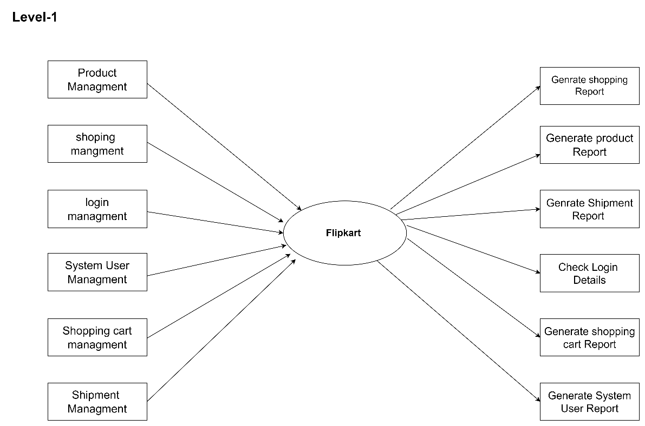

**5. What is Flow chart? Create a flowchart to make addition of two numbers.**

-> A flowchart is a visual representation of a process or algorithm, using symbols and arrows to illustrate the sequence of steps or decisions involved.

->

Input a,b

Print sum

Sum=a+b

**6. What is Use case Diagram? Create a** **use-case on bill payment on Paytm.**

-> A use case diagram is a graphical representation in the Unified Modeling Language (UML) that depicts how users interact with a system or software application.

- use-case on bill payment on Paytm.

